# 20200616
https://ui.sage/grafana/d/status/status-page?orgId=82
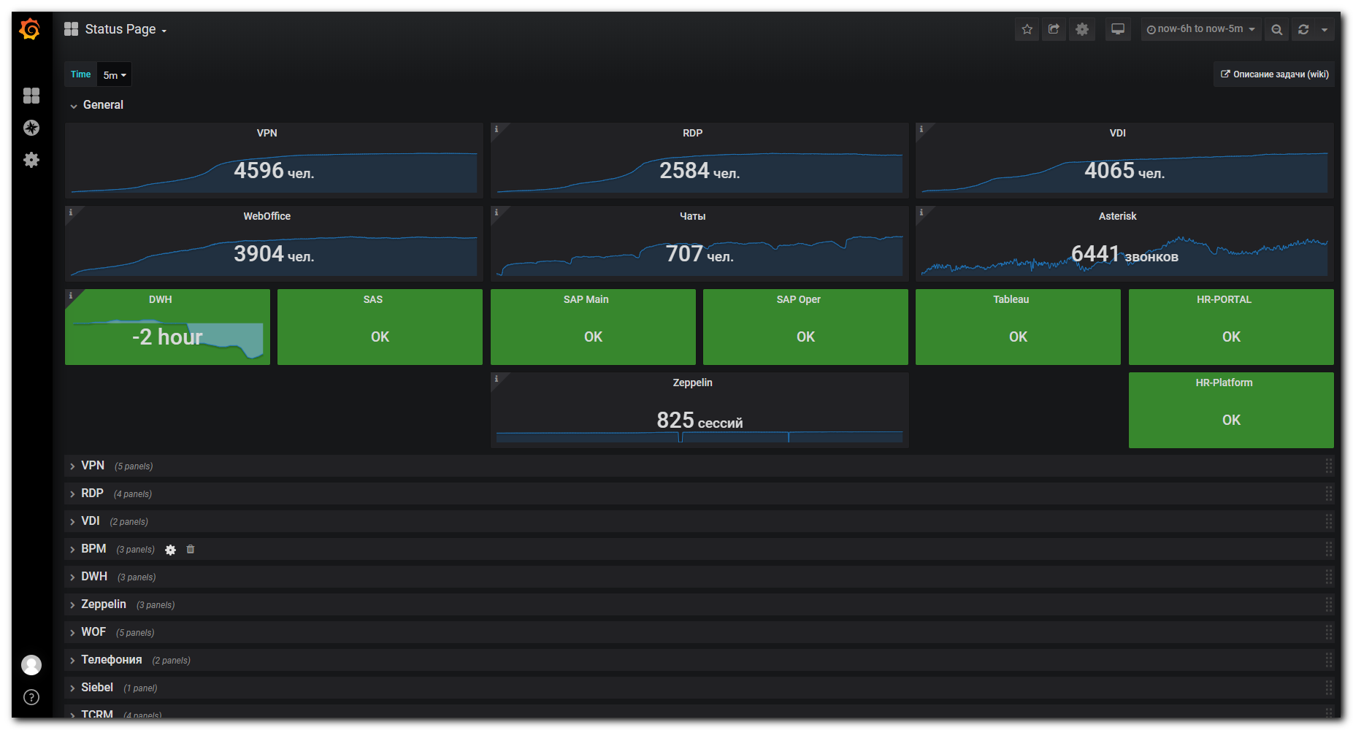
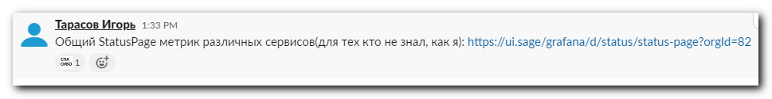

# 20200615
https://vm-graphite01p.tcsbank.ru/d/5Lk7a3jWk/vcs-status-general?orgId=1&refresh=5s
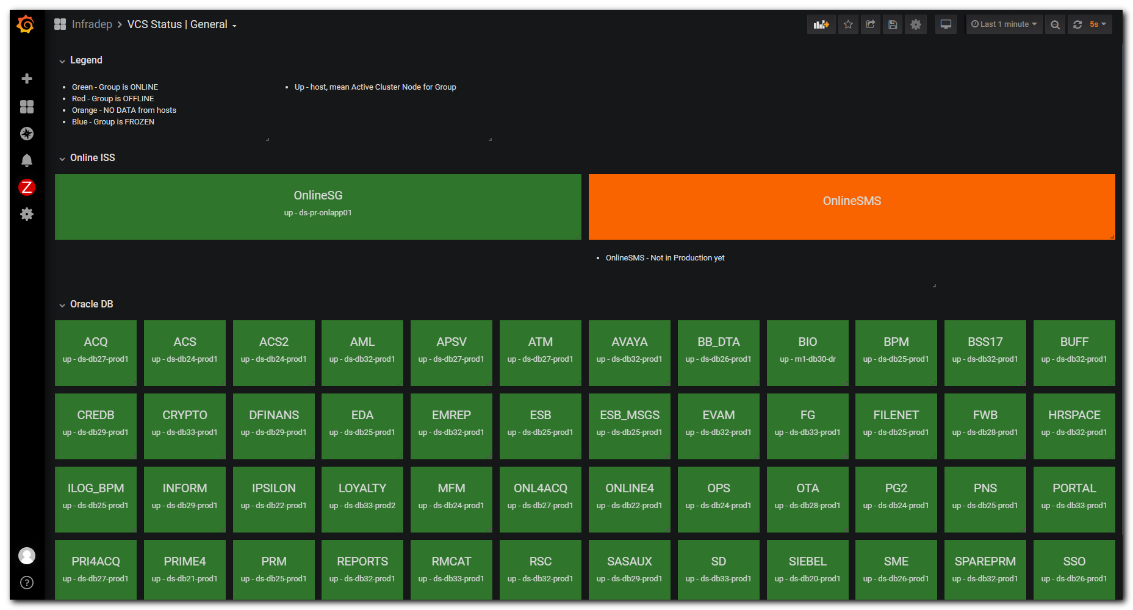
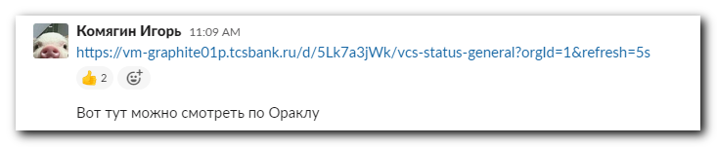
# 20200615

https://ds-na-harvest-graf01/d/ULZYMifWk/database-arrays-aggregate-perf?orgId=1&from=now-3h&to=now&refresh=1m
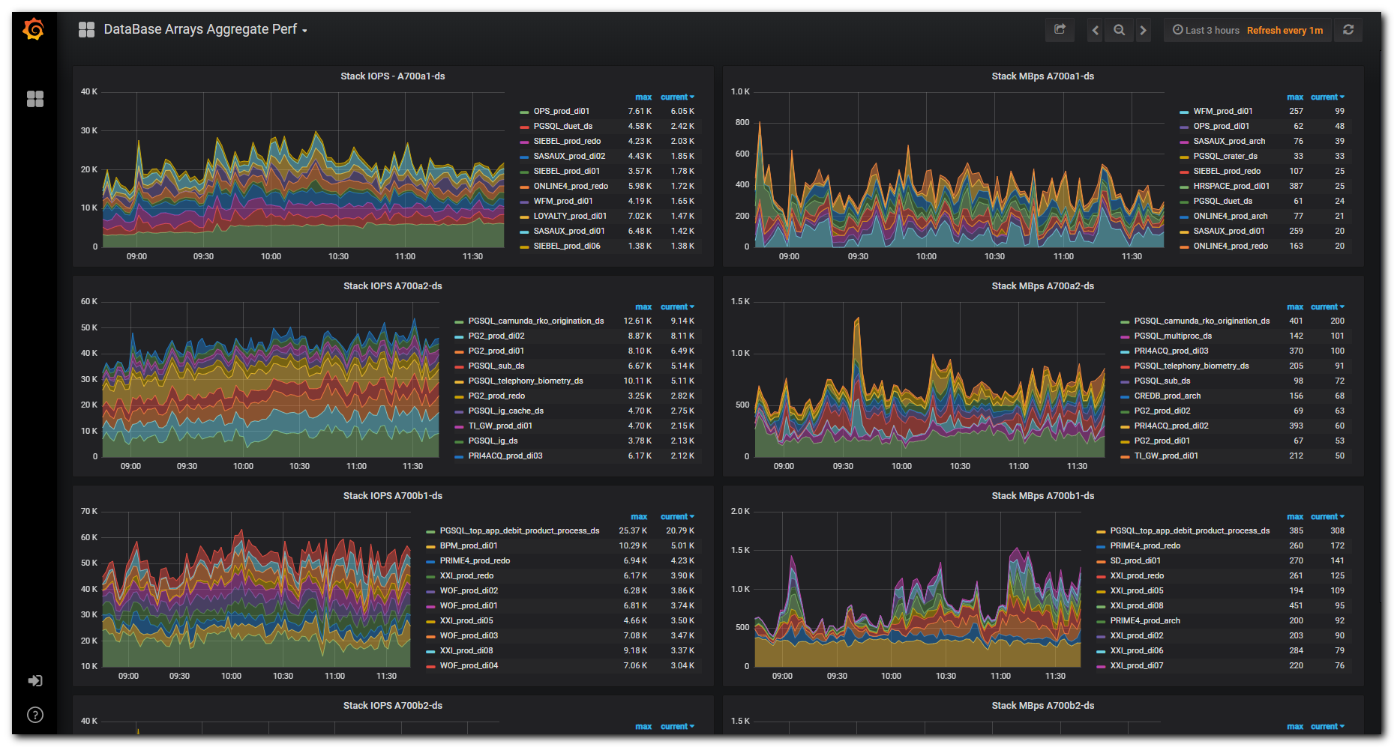

https://ds-na-harvest-graf01/d/Dw4WCnbmk/oracle-database-top-volumes-iops-mb-s-a700-prod?refresh=1m&orgId=1
